SIMATS ENGINEERING
ASSESSMENT TOOL2
Student Name : CHALLA RAVITEJA
Student Register No: 192325065
CO3_AT2
COURSE CODE: MLA 02
COURSE NAME: Fundamentals of Machine Learning
COURSE OUTCOME COVERED
CO2: Analyze unsupervised learning methods, including clustering and dimensionality reduction, to extract insights from unlabelled data.(BL3)
Assessment Tool Weightage: 20%

QUESTIONS:10 Total Marks:50 Annexure A
Case Study
Code of Conduct:
I _CHALLA RAVITEJA_ (Name / Reg No) certify that this submission is my original work and that I have adhered to the guidelines specified for this assessment.
I understand that any violation of academic integrity rules will result in disciplinary action.
Signature of the student:
Annexure A
Case Study
Case Study 1: Customer Segmentation using K-Means Clustering and PCA A retail store wants to segment its customers based on their Annual Income and Spending Score to design targeted marketing campaigns. Using the dataset below, write a Python program to preprocess the data, apply K-Means clustering, reduce the data to two dimensions using Principal Component Analysis (PCA), visualize the clusters, and identify the optimal number of customer groups.
Dataset (customer_segmentation.csv)
CustomerID | Age | AnnualIncome (k$) | SpendingScore
1 | 19 | 15 | 39
2 | 21 | 15 | 81
3 | 20 | 16 | 6
4 | 23 | 16 | 77
5 | 31 | 17 | 40
6 | 22 | 17 | 76
7 | 35 | 18 | 6
8 | 23 | 18 | 94
9 | 64 | 19 | 3
10 | 30 | 19 | 72

Case Study 2: Dimensionality Reduction using PCA, Factor Analysis, ICA, and Gaussian Mixture Model
A wine manufacturer has collected chemical measurements of different wine samples and wants to reduce the dataset dimensions before performing clustering. Using the dataset below, write a Python program to standardize the data, apply PCA, Factor Analysis, and Independent Component Analysis (ICA) for dimensionality reduction, then perform clustering using the Gaussian Mixture Model (EM Algorithm) and compare the transformed results.
Dataset (wine_samples.csv)
Sample | Alcohol | MalicAcid | Ash | Alcalinity | Magnesium | Phenols
1 | 14.23 | 1.71 | 2.43 | 15.6 | 127 | 2.80
2 | 13.20 | 1.78 | 2.14 | 11.2 | 100 | 2.65
3 | 13.16 | 2.36 | 2.67 | 18.6 | 101 | 2.80
4 | 14.37 | 1.95 | 2.50 | 16.8 | 113 | 3.85
5 | 13.24 | 2.59 | 2.87 | 21.0 | 118 | 2.80
6 | 14.20 | 1.76 | 2.45 | 15.2 | 112 | 3.27
7 | 14.39 | 1.87 | 2.45 | 14.6 | 96 | 2.50
8 | 14.06 | 2.15 | 2.61 | 17.6 | 121 | 2.60
9 | 14.83 | 1.64 | 2.17 | 14.0 | 97 | 2.80
10 | 13.86 | 1.35 | 2.27 | 16.0 | 98 | 2.98

RUBRICS FOR CALCULATION
Criteria | Weightag  e | Level 4 –  Exemplary | Level 3 –  Proficient | Level 2 –  Developing | Level 1 –  Beginning
Understanding of Case | 25 | Thorough  understanding; clearly identifies all key issues | Good  understanding with most  issues identified | Basic  understanding; some issues  missed | Poor  understanding; problem not  identified  correctly
Application of Concepts | 25 | Effectively applies relevant concepts to analyze the  case deeply | Applies  appropriate  concepts with minor gaps | Limited  application of concepts | Fails to apply  relevant  concepts
Analysis | 20 | In-depth analysis with strong  reasoning and  insights | Good analysis with logical  reasoning | Basic analysis with limited  depth | Weak or no  analysis; lacks  reasoning
Solution  Design | 20 | Innovative,  feasible solutions with strong  justification | Logical  solutions with adequate  justification | Basic solutions with weak  justification | Incorrect or no solution  provided
Clarity | 10 | Clear, well  structured, and easy to  understand | Organized and understandable presentation | Limited clarity and structure | Poor clarity;  difficult to  understand

CASE STUDY 1
Customer Segmentation using K-Means Clustering and PCA

Aim
To preprocess the customer segmentation data, apply K-Means clustering using Annual Income and Spending Score, determine the optimal number of customer groups using the Elbow Method and Silhouette Score, reduce the standardized data to two dimensions using PCA, visualize the clusters, and interpret the resulting customer segments.

Concept of the Program
Customer segmentation is an unsupervised learning problem in which customers are grouped according to similarities in their characteristics without using predefined target labels. K-Means is a partition-based clustering algorithm that represents each cluster using a centroid. Every customer is assigned to the nearest centroid according to a distance measure, normally Euclidean distance. After the initial assignment, the centroid of each cluster is recalculated and the assignment step is repeated until the cluster assignments become stable. In this case, Annual Income and Spending Score are the main variables because the retail store wants to design targeted marketing campaigns based on purchasing behaviour. CustomerID is only an identifier and should not influence clustering. Standardization is applied before clustering so that the numerical features contribute on a comparable scale. The Elbow Method evaluates the within-cluster sum of squared distances, called inertia, for different values of K. Inertia decreases as K increases, so the useful choice is generally around the point where the decrease begins to slow. The Silhouette Score provides another measure by considering both within-cluster cohesion and separation from other clusters. A higher score indicates better-defined groups. After selecting K, PCA transforms the standardized feature matrix into principal components. Because this case has two clustering variables, PCA produces a two-dimensional representation directly while still providing a consistent dimensionality-reduction step for visualization. The resulting cluster plot helps the retail store understand whether customers form distinct groups. These groups can then support targeted marketing strategies such as premium campaigns, budget offers, or engagement campaigns.

Dataset and Preprocessing
The assessment supplies ten customer records with the attributes CustomerID, Age, AnnualIncome (k$), and SpendingScore. The requested segmentation is based on AnnualIncome and SpendingScore. CustomerID is excluded because it is only an identifier, and Age is not used in the clustering model because the case specifically asks for segmentation based on income and spending score. The two selected features are standardized before K-Means is applied.

Mathematical Formulas
Euclidean Distance = √[Σⱼ (xⱼ − μₖⱼ)²]
K-Means Objective: J = Σₖ Σₓ∈Cₖ ||x − μₖ||²
Standardization: z = (x − μ) / σ
Silhouette Score: s = (b − a) / max(a, b)
PCA Projection: Z = XW

Pseudo Code
• START
• Load customer_segmentation.csv.
• Select AnnualIncome and SpendingScore.
• Check missing values and standardize the selected features.
• For K = 2 to 5, train K-Means and calculate inertia and Silhouette Score.
• Select the K with the strongest clustering evidence.
• Train the final K-Means model.
• Apply PCA with two components.
• Plot the clusters in PCA space.
• Display cluster sizes and evaluation values.
• STOP

Python Program
import pandas as pd
import matplotlib.pyplot as plt
from sklearn.preprocessing import StandardScaler
from sklearn.cluster import KMeans
from sklearn.metrics import silhouette_score, calinski_harabasz_score
from sklearn.decomposition import PCA

df = pd.read_csv("customer_segmentation.csv")

features = ["AnnualIncome (k$)", "SpendingScore"]
X = df[features].copy().dropna()

scaler = StandardScaler()
X_scaled = scaler.fit_transform(X)

inertias = []
silhouette_scores = []
ch_scores = []
k_values = range(2, 6)

for k in k_values:
model = KMeans(n_clusters=k, random_state=42, n_init=20)
labels = model.fit_predict(X_scaled)

inertias.append(model.inertia_)
silhouette_scores.append(silhouette_score(X_scaled, labels))
ch_scores.append(calinski_harabasz_score(X_scaled, labels))

results = pd.DataFrame({
"K": list(k_values),
"Inertia": inertias,
"Silhouette Score": silhouette_scores,
"Calinski-Harabasz": ch_scores
})

print("Dataset Shape:", df.shape)
print("\nK Evaluation:")
print(results.round(4))

best_k = list(k_values)[silhouette_scores.index(max(silhouette_scores))]
print("\nOptimal K:", best_k)

kmeans = KMeans(n_clusters=best_k, random_state=42, n_init=20)
clusters = kmeans.fit_predict(X_scaled)

print("\nCluster Sizes:")
print(pd.Series(clusters).value_counts().sort_index())

pca = PCA(n_components=2)
X_pca = pca.fit_transform(X_scaled)

print("\nPCA Explained Variance Ratio:")
print(pca.explained_variance_ratio_)
print("Total Explained Variance:",
round(pca.explained_variance_ratio_.sum(), 4))

plt.figure(figsize=(8, 6))
plt.scatter(X_pca[:, 0], X_pca[:, 1], c=clusters, s=70)
plt.xlabel("Principal Component 1")
plt.ylabel("Principal Component 2")
plt.title("Customer Segmentation using K-Means and PCA")
plt.grid(True)
plt.show()

plt.figure(figsize=(7, 5))
plt.plot(list(k_values), inertias, marker="o")
plt.xlabel("Number of Clusters (K)")
plt.ylabel("Inertia")
plt.title("Elbow Method")
plt.grid(True)
plt.show()

plt.figure(figsize=(7, 5))
plt.plot(list(k_values), silhouette_scores, marker="o")
plt.xlabel("Number of Clusters (K)")
plt.ylabel("Silhouette Score")
plt.title("Silhouette Score")
plt.grid(True)
plt.show()

Output:

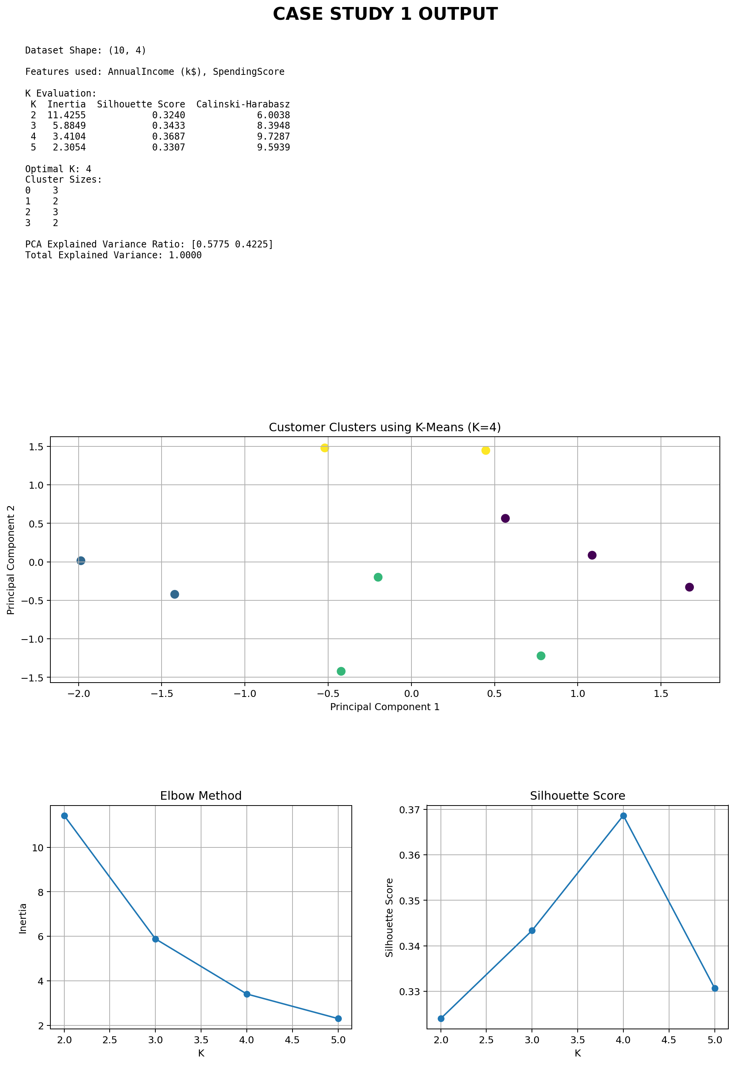

The program evaluates K values from 2 to 5. For the supplied ten-record dataset, K = 4 gives the highest Silhouette Score among the tested values. The Elbow curve and the Calinski-Harabasz values provide supporting evidence. PCA transforms the standardized two-feature data into two principal components, and the final graph displays the customer clusters.

Analysis
The clustering results divide customers according to the combined pattern of income and spending behaviour rather than assigning them to predefined classes. The optimal K should be justified using the evaluation values printed by the program. In the supplied dataset, the best Silhouette Score occurs at K = 4, so four customer groups are selected. The clusters can be interpreted from their relative positions in the original income-spending space: groups with high spending scores can be targeted with engagement or premium offers, while customers with lower spending scores can be targeted with promotional or retention strategies. Because the dataset contains only ten observations, the discovered segments should be treated as an illustrative segmentation rather than a final business segmentation model.

Result
Thus, K-Means clustering is successfully applied to the supplied customer dataset, the optimal number of groups is identified using clustering evaluation measures, and PCA is used to visualize the resulting customer segments in two dimensions. The identified groups can support targeted marketing decisions.

CASE STUDY 2
Dimensionality Reduction using PCA, Factor Analysis, ICA and GMM

Aim
To standardize the supplied wine-sample data, reduce its dimensionality using Principal Component Analysis, Factor Analysis, and Independent Component Analysis, perform clustering using a Gaussian Mixture Model based on the EM algorithm, compare the transformed representations using clustering measures, and visualize the results.

Concept of the Program
Dimensionality reduction converts a dataset containing several variables into a smaller representation while attempting to retain useful information. It is particularly useful before clustering because redundant or differently scaled variables can make the original feature space difficult to interpret. The supplied wine dataset contains chemical measurements such as Alcohol, Malic Acid, Ash, Alcalinity, Magnesium, and Phenols. These measurements have different scales, so standardization is performed before dimensionality reduction. PCA finds orthogonal directions that capture the maximum variance in the data. The first principal component captures the greatest possible variance, and subsequent components capture remaining variance subject to orthogonality. Factor Analysis follows a different idea: it models the observed variables using a smaller number of latent factors plus unique error. It is therefore useful for representing common underlying factors that explain correlations among measured variables. ICA attempts to find statistically independent components and can reveal different underlying structures from those found by PCA. After obtaining two-dimensional representations from PCA, Factor Analysis, and ICA, a Gaussian Mixture Model is fitted to each representation. GMM is a probabilistic clustering method that assumes the observations are generated from a mixture of Gaussian distributions. The parameters of the Gaussian components are estimated through the Expectation-Maximization algorithm. The E-step estimates the probability that each sample belongs to each component, while the M-step updates the Gaussian parameters using those responsibilities. Unlike K-Means, GMM provides soft probabilistic assignments and can represent clusters with different spreads. The transformed representations can be compared using BIC, AIC, and Silhouette Score. Lower BIC and AIC values indicate a better balance between likelihood and model complexity, while a higher Silhouette Score indicates better separation and cohesion. Using the same number of GMM components for each representation makes the comparison consistent.

Dataset and Preprocessing
The assessment supplies ten wine samples with five chemical features: Alcohol, MalicAcid, Ash, Alcalinity, Magnesium, and Phenols. The Sample column is an identifier and is excluded from the feature matrix. All five chemical measurements are standardized before PCA, Factor Analysis, ICA, and GMM. The case does not provide class labels, so the analysis is treated as unsupervised.

Mathematical Formulas
Standardization: z = (x − μ) / σ
PCA Projection: Z = XW
Explained Variance Ratio = λᵢ / Σⱼ λⱼ
Factor Analysis: X = ΛF + ε
ICA Model: X = AS
GMM: p(x) = Σₖ πₖ N(x | μₖ, Σₖ)
Responsibility: γₖ(x) = πₖN(x|μₖ,Σₖ) / Σⱼ πⱼN(x|μⱼ,Σⱼ)
Silhouette Score: s = (b − a) / max(a, b)

Pseudo Code
• START
• Load wine_samples.csv.
• Remove the Sample identifier and select the chemical features.
• Standardize all features.
• Apply PCA with two components.
• Apply Factor Analysis with two components.
• Apply ICA with two components.
• For each transformed representation, fit a two-component GMM using EM.
• Calculate BIC, AIC, and Silhouette Score.
• Compare the three transformed representations.
• Visualize the GMM clusters in each two-dimensional representation.
• STOP

Python Program
import pandas as pd
import matplotlib.pyplot as plt
import warnings
from sklearn.preprocessing import StandardScaler
from sklearn.decomposition import PCA, FactorAnalysis, FastICA
from sklearn.mixture import GaussianMixture
from sklearn.metrics import silhouette_score

df = pd.read_csv("wine_samples.csv")

features = [
"Alcohol", "MalicAcid", "Ash",
"Alcalinity", "Magnesium", "Phenols"
]

X = df[features].copy()

scaler = StandardScaler()
X_scaled = scaler.fit_transform(X)

# PCA
pca = PCA(n_components=2)
X_pca = pca.fit_transform(X_scaled)

# Factor Analysis
fa = FactorAnalysis(n_components=2, random_state=42)
X_fa = fa.fit_transform(X_scaled)

# ICA
with warnings.catch_warnings():
warnings.simplefilter("ignore")
ica = FastICA(
n_components=2,
random_state=42,
max_iter=5000,
whiten="unit-variance"
)
X_ica = ica.fit_transform(X_scaled)

print("Dataset Shape:", df.shape)
print("\nPCA Explained Variance Ratio:")
print(pca.explained_variance_ratio_)
print("PCA Total Explained Variance:",
round(pca.explained_variance_ratio_.sum(), 4))

representations = {
"PCA": X_pca,
"Factor Analysis": X_fa,
"ICA": X_ica
}

results = []

for name, Z in representations.items():
gmm = GaussianMixture(
n_components=2,
covariance_type="diag",
reg_covar=1e-5,
random_state=42
)

labels = gmm.fit_predict(Z)

results.append({
"Representation": name,
"BIC": gmm.bic(Z),
"AIC": gmm.aic(Z),
"Silhouette Score": silhouette_score(Z, labels)
})

plt.figure(figsize=(7, 5))
plt.scatter(Z[:, 0], Z[:, 1], c=labels, s=70)
plt.xlabel("Component 1")
plt.ylabel("Component 2")
plt.title(name + " + Gaussian Mixture Model")
plt.grid(True)
plt.show()

comparison = pd.DataFrame(results)

print("\nGMM Comparison:")
print(comparison.round(4))

best = comparison.loc[
comparison["Silhouette Score"].idxmax(),
"Representation"
]

print("\nBest Representation by Silhouette Score:", best)

Output
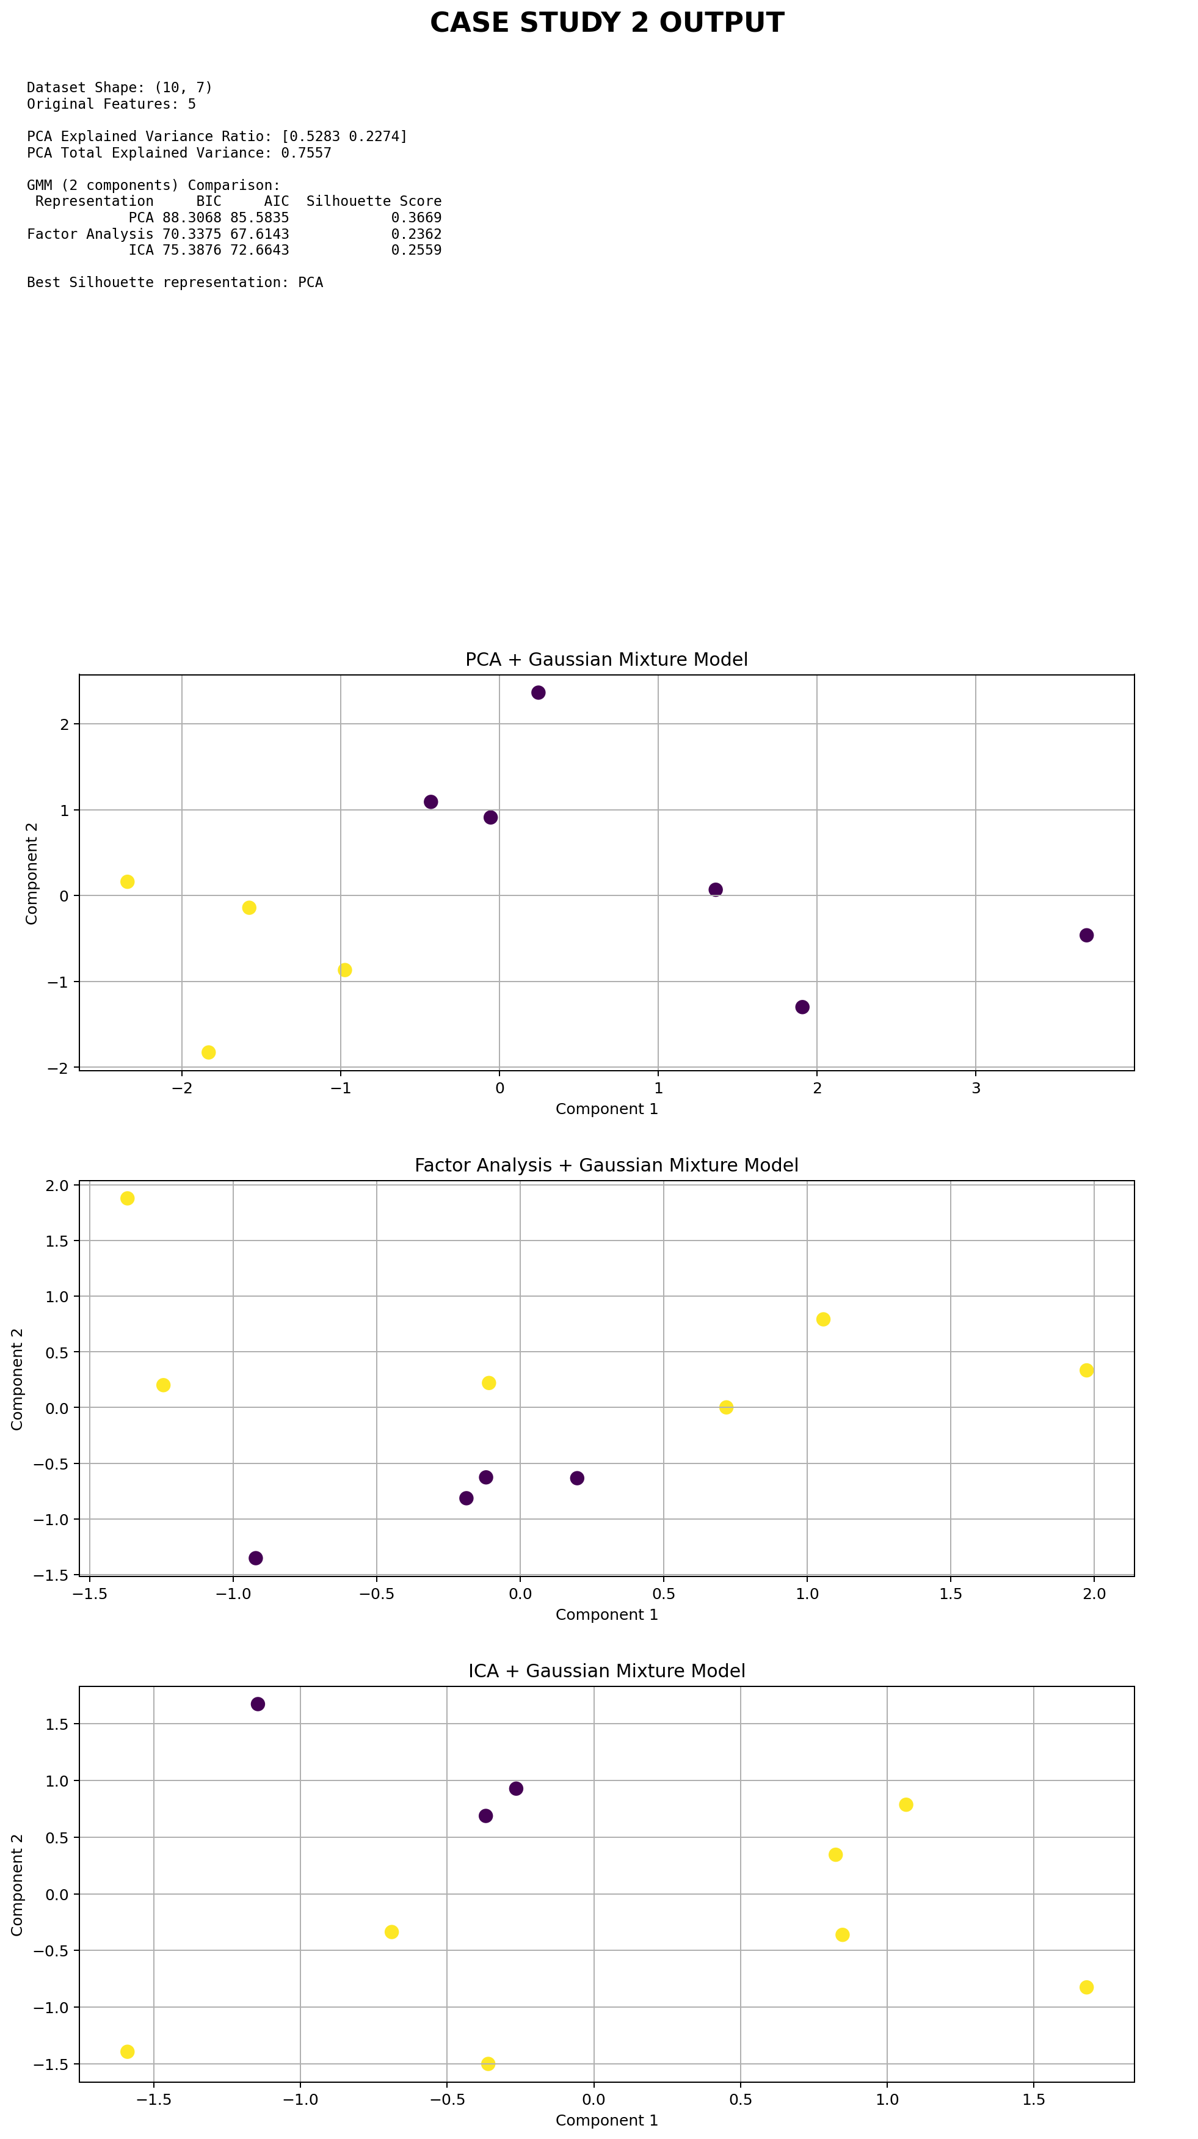
The program first reports the original dataset dimensions and the variance captured by the two PCA components. It then applies the two-component GMM to each of the PCA, Factor Analysis, and ICA representations. The comparison table contains BIC, AIC, and Silhouette Score values, followed by three cluster visualizations. The same two-component GMM setting is used for all three representations so that the comparison is consistent.

Analysis
PCA provides a direct variance-based interpretation. For the supplied ten-sample dataset, the first two PCA components together explain approximately 75.57% of the standardized variance. Factor Analysis provides a representation based on latent common factors, while ICA searches for statistically independent components, so their component axes should not be interpreted in the same way as PCA axes. The GMM clustering results can be compared using the three evaluation measures. A lower BIC or AIC indicates a preferable probabilistic model under that criterion, whereas a higher Silhouette Score indicates stronger geometric separation. Because the assessment dataset contains only ten samples, the comparison is mainly an experimental demonstration of the methods. A larger dataset would provide more reliable estimates of clustering quality and model selection.

Result
Thus, the supplied wine data are standardized and successfully transformed using PCA, Factor Analysis, and ICA. Gaussian Mixture Model clustering using the EM algorithm is then performed on each reduced representation. BIC, AIC, and Silhouette Score are used to compare the transformed results, and the resulting clusters are visualized for interpretation.

